**Student Name:** Darshit Modi  
**ID:** 4961714  
**Tutor Name:** Tanjila Kanij   
**Team members:**   
Josh Hardy (7678282)  
Gurkeerat Singh (100023641)  
Luke Sutherland (1751328)

__________________________________________________________________________________

**4.2 Sprint 1 - Week 1:**

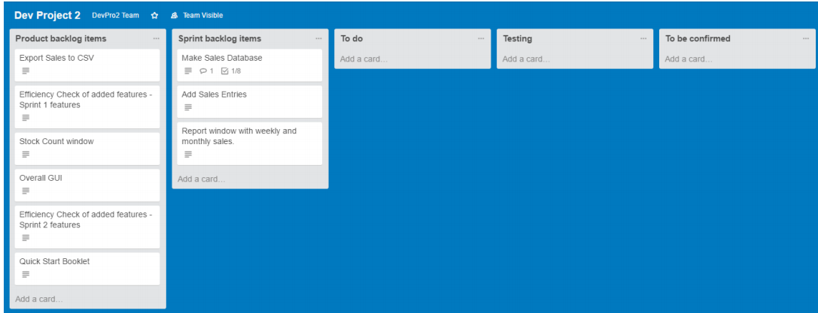**Trello task board: (Days 1-5):  
Days 1-4:**

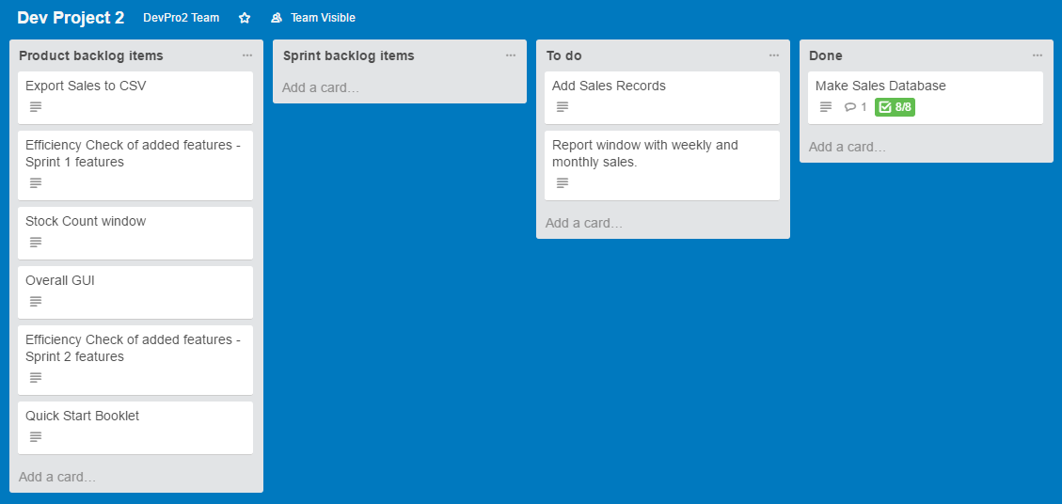**Day 5:**

**GitHub Repository:**

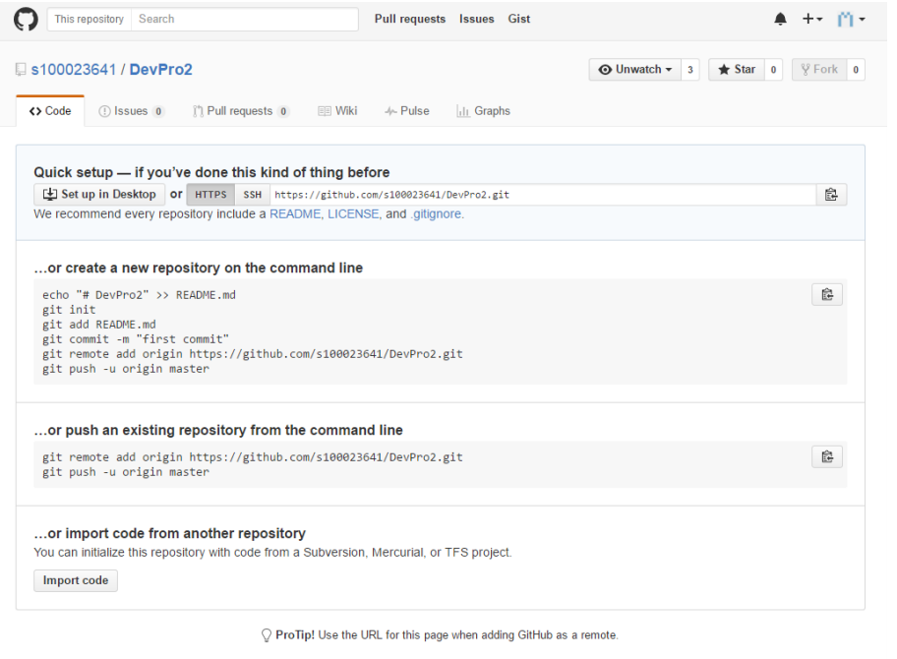**Days 1-4: (No work was done between these days so GitHub was not updated)**

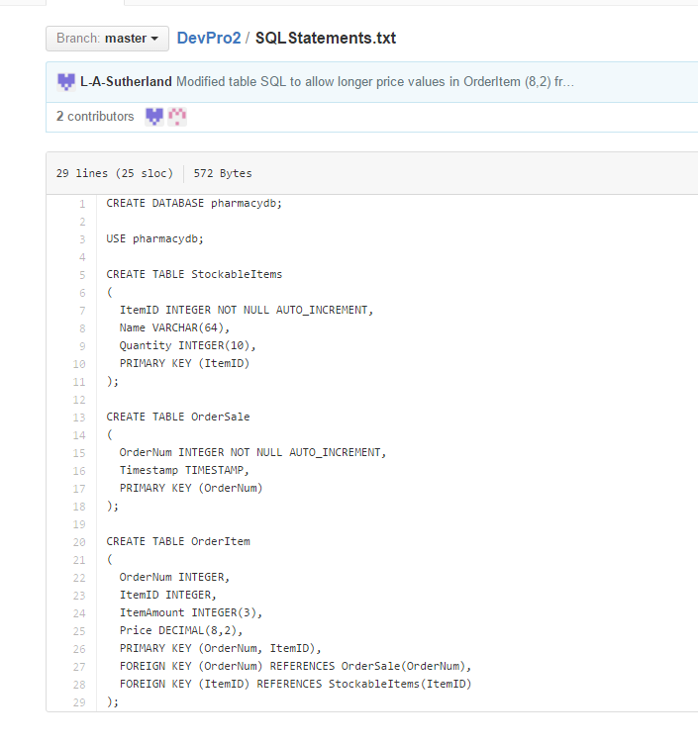**Day 5:**

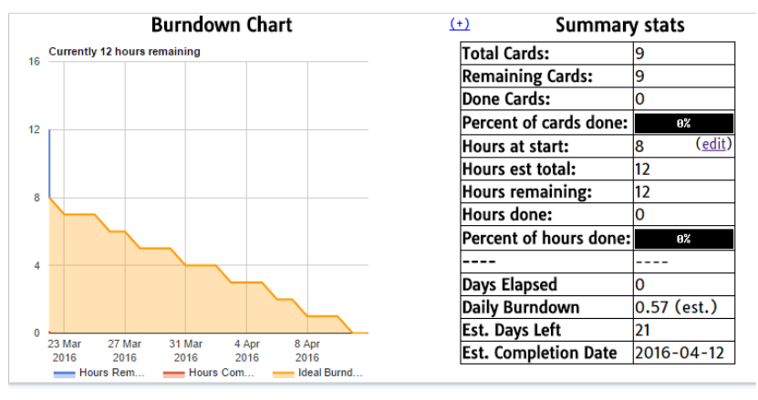**Burndown Chart:**